**INFORMATION SYSTEMS IN CONSTRUCTION SECTOR**

by

D. Shashank - 13BCE1036

K. Gourav - 13BCE1068

S. Chanakya - 13BCE1162

*A project report submitted to the*

**SCHOOL OF COMPUTING SCIENCES AND ENGINEERING**

*In partial fulfillment of the award for degree*

*of*

**BACHELOR OF TECHNOLOGY**

*in*

**COMPUTER SCIENCE ENGINEERING**



**VIT UNIVERSITY, CHENNAI**

**Vandalur – Kelambakkam Road**

**Chennai – 600 127.**

**OCTOBER 2015**

**ACKNOWLEDGEMENT**

We wish to express our sincere thanks and deep sense of gratitude to our project guide, **Prof. Christy Jackson J,** Associate Professor, School of Computing Sciences and Engineering, for his consistent encouragement and valuable guidance offered to us in a pleasant manner throughout the course of the project work.

We also take this opportunity to thank all the faculty of the School for their support and their wisdom imparted to us throughout the course.

We thank our parents, family, and friends for bearing with us throughout the course of our project and for the opportunity they provided us in undergoing this course in such a prestigious institution.

**Shashank. D Gourav. K Chanakya. S**

**TABLE OF CONTENTS**

1. Introduction
2. What happens in a Construction Sector
3. Strategic planning in Construction Sector
4. Types of Information Systems that can be used in Construction Sector
5. Reasons to adopt information systems
6. Softwares that can be used
7. Statistics

**INTRODUCTION**

Information system can be interpreted as a tool which enhances the organization through different technical and smart methodologies so as to reduce human effort, time and irrelevant investment wastage.

It is not only the information technology that are being used in the organization. Information system is somewhat different from that. Information system gives reports, enhances ways of generating reports and gives an interface between the organization and its performance.

Construction Sector is one of the consistent sectors in the economy/market since it has many factors affecting it in which one such example is increase in population which leads to increase in demand of construction of shelter/apartments and else. In countries like India, usage of information technology and information systems in construction sector constitutes a very less percentage. For example, in countries like Dubai, for construction also, a lot of machinery and robotics is used for more accuracy and to have a significant duration benefits where as in India, manpower is used.

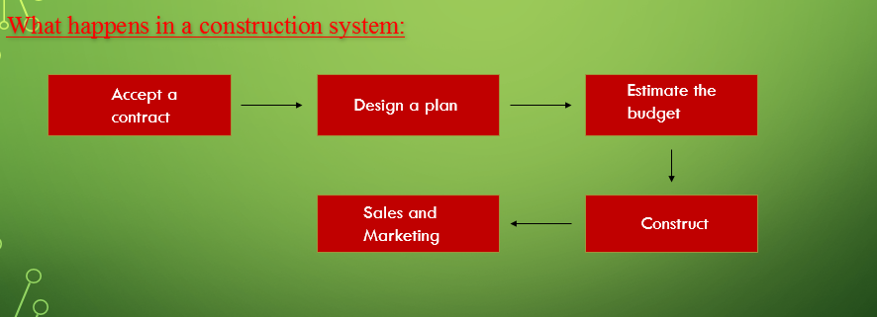

**Accept a Contract:**

Contracts are not obtained as such when the company enters the field.

The company has to publicize itself and place tenders for several government take – ups (if interested). In order to gain experience and trust, few normal government projects have to be done because people hesitate giving contracts to new ones.

If suppose, a private contract has arrived, conditions like land value in the area, permission restrictions, approximate population in the region etc. factors have to be considered and checked before taking the land and starting construction.

**Design a plan:**

A plan has to be designed for construction of buildings, apartments etc. Pan doesn’t mean that a step of procedures should be maintained. It is the front view and side view of the construction. For some constructions, we may need the top view also.

Using the plan, we need to calculate the raw materials needed. For example, to construct a wall of 10x15 feet with a brick size of 1x0.3 feet, we need 500 bricks. This is for one side and just for bricks. Estimation and calculation must be done for the whole building and a perfect list of materials need to be prepared.

No company use their raw materials efficiently, so for each raw materials, a bench mark of 2% of it is added.

**Estimate the budget:**

This is the next most crucial part in construction industry. The survival of the contract, company etc. depends on the estimation of budget.

The workers’ salary, engineers, managers – their salaries, government clearances, material costs, model flats constructions, furniture's cost, office branch construction.

Company benefits such as transport, sim cards etc. should be issued to the executives’ part of the job.

For sustainable reasons, a grace budget of 10 to 12% is estimated more.

**Construction:**

Man power and now of days have to be estimated and a daily procedure has to be followed.

Timelines and check points have to be maintained.

Cranes, Construction vehicles, bore installer machines, rock breaking machines etc. have to be taken for rent as per the requirement.

Construction should happen smoothly.

Safety should be taken care of.

Children should not be allowed in the construction part which violates the ethical principle of child labor.

**Sales and Marketing:**

This is the most challenging phase of construction business.

Stalls have to be installed in exhibitions, ads should be given, model flat should be made, brochures should be made and sales have to be promoted.

Websites, social media etc. are also adopted in some construction companies.

Opening sales should be given with some discount such that the profit function does not get effected much.

Usually, profit is calculated per square feet. So, the current value of land during the time of sales should also be taken into consideration.

All the above mentioned aspects are taken into consideration in construction sector so as to obtain and accomplish a full – fledged project.

**Strategic Plan of a Construction Sector:**

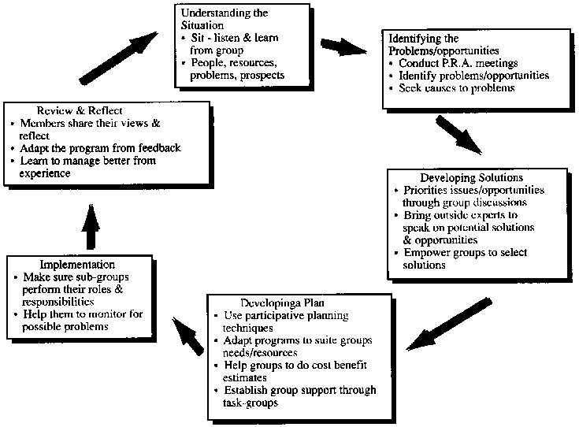

The types of information systems that can be used in Construction Sector are:

1. Executive Support Systems: This type of information system can be set up to have an efficient budget forecasting, sales forecasting, profit planning and personnel planning.
2. Management Information Systems and Decision Support Systems: This type of information systems can be used for sales management, Inventory control, annual budgeting, capital investing analysis, relocation analysis, cost analysis, pricing and profitability analysis.
3. Knowledge Based Expert Systems: Since it is the construction sector, there would be engineering workstations, graphics workstations, document imaging and several other areas where knowledge systems might be a use of. These systems are in progress.



1. Transaction Processing Systems: In the process of sales and marketing, we would have order tracking and processing. Not only that but also cash management, employee record maintenance, Payroll, accounts payable and receivable are some of the areas where we can use transaction processing systems.



**Reasons for the adoptions of information systems in construction industry:**

1. Every construction project is unique and projects constitutes high level of risks and uncertainties.
2. Strong resistance of personnel to adoption of new techniques and lack of adapting towards the advancement of technology results in low productivity compared to other industries.
3. Low investments on R & D in construction systems. Leading Japan companies contribute 1% of their annual turnover towards R & D in construction industry which is why Japan has automated robotic systems usage in construction industry.

According to the Planning commission, Govt. of India, the investment statistics on construction sector is as follows:



Several techniques and softwares can also be used in construction industry for better functionality, accuracy, reducing time etc. Few types of softwares that can be used are:

**Building Information Modelling Software (BIM):** Can be used for modelling and visualization of how the project looks, how can the project be constructed, the projections and views of constructions.

Examples: Autodesk Revit, ArchiCAD, Microstation, Solidworks etc.

**Energy Simulation Tools:** Can be used for analysis of energy performance and visualization of results to support decision making.

Examples: IES, Ecotect, Design Builder, Esp – r, Energy Plus etc.

**Building Environment Assessment tools (BEA):** Can be used for building the environmental impact.

Examples: Envest II

**Life cycle Assessment tools (LCA):** Can be used for material lifecycle performance.

Examples: SimaPro, BEES, Athena Environmental Impact Estimator etc.

**Life cycle Cost Assessment tools (LCCA):** Can be used for Life cycle cost Assessments.

Examples: Building Life Cycle Cost (BLCC), Envest II, IES etc.



The above figure represents Information systems used by **Hyundai**.

**Statistics:**

As mentioned before, in countries like India, we do not use information systems and technology in construction sector, rather we use manpower.

The following is the statistics of how long information systems are used by companies and for what reasons are they used.





E-procurement gov.in is a comprehensive e-infrastructure in India that helps the government and society by providing a robust automated platform in construction sector which provide services of e-procurement, e-tendering, e-selling, e-auctions etc. India is a developing country where Construction sector contributes to only 8% of the GDP and the following is the statistics of Indian investment on e-procurement both by public and private tenders.



Even though manpower is used, India is in lack of manpower. According to research taken up by IIT Kanpur,

In 1995-96, approximately *1.50* Crores of people were employed in this industry which is expected to be *3.26* Crores by the year 2004-2005 (Das, 2003). There are three categories of manpower involved in this industry consisting of the artisan level, the supervisory level and managerial level. It has been observed that every *Rs.1 Crore*, investment on construction project, generates employments of *22,000* unskilled man-days, *23,000* skilled or semiskilled man-days and *9,000* managerial and technical man-days approximately. With only 3% of total teaching in the country addressing the direct needs of the construction engineering and management aspects required in the construction industry, the 14th Engineering Congress on Human Capital Development in January 2002 observed that “*in time to come, India will not have sufficient quality civil engineers even to undertake basic infrastructure work*.” Urgent steps are to be initiated to reverse this trend of severe shortage of technical manpower.

Manpower should be used but technical manpower where brains are required should be used and information systems must be used to automate things which can be done without using manpower. So, unless and until both manpower and information systems go hand in hand in the righteous manner, India’s construction sector would be in the developing stage.

**References:**

<http://www.jacic.or.jp/acit/indian_national.pdf>

<http://www.iitk.ac.in/nicee/RP/2004_Challenges_Construction_Industry_Proceedings.pdf>

<http://www.irbnet.de/daten/iconda/CIB_DC23705.pdf>

<http://www.iaarc.org/publications/fulltext/Construction_information_system_itegrating_data_information_systems_and_expert_systems.pdf>

<https://www.wikipedia.org/>